To Review Fluid Codes

- Bulkload new FC’s
- If SP3D is open, exit session and re-enter SP3D
- Access SP3D Piping task
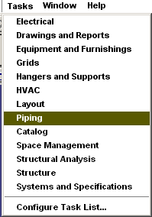
- Set the Locate Filter to ALL
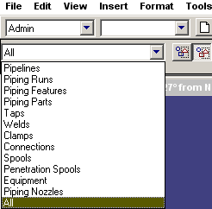
- Right click on a Pipeline System and select Properties
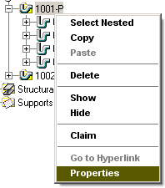
- Click the Fluid Requirement field, select a desired fluid system from the drop down list
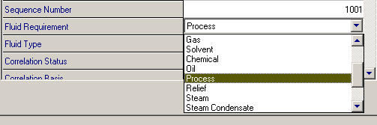
- Click the Fluid Type field, select a desired fluid code from the pull down list
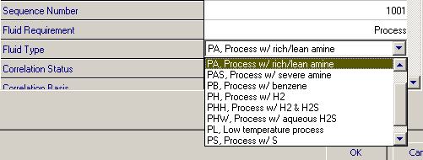
- Cancel the Pipeline properties form, unless you need to change the FC for this pipeline

